By sign in to the website “openweathermap.org”.

Then created Api keys -> go to account🡪 click on my Api keys



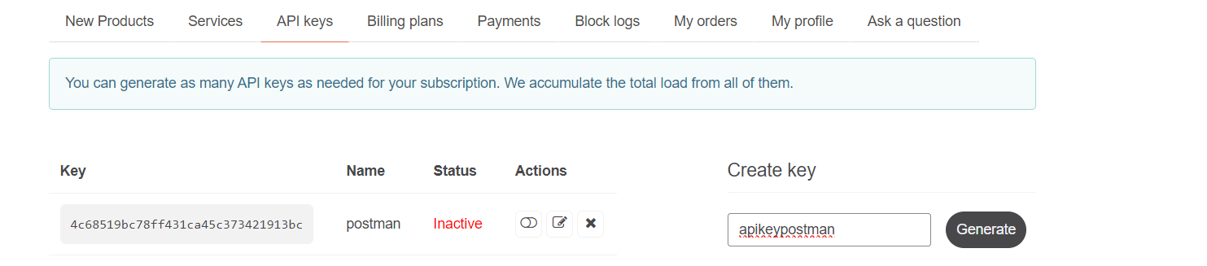

Given name to key and click on Generate.

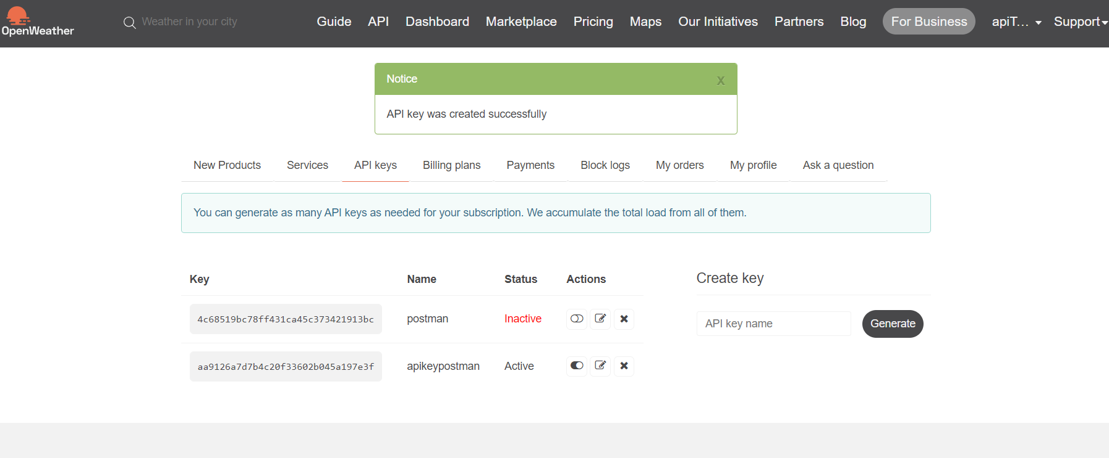

The Api request we will use is :

[https://api.openweathermap.org/data/2.5/weather?q=London&appid={give](https://api.openweathermap.org/data/2.5/weather?q=London&appid=%7bgive) api key}

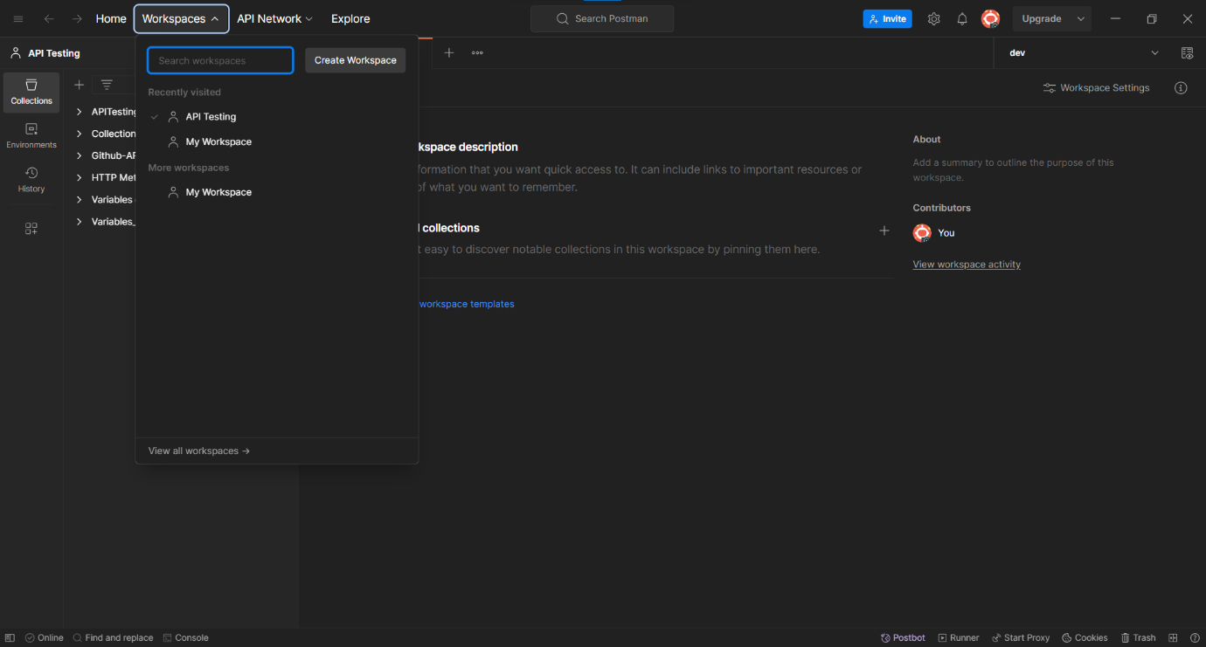Creating a Workspace in postman by click on the workspaces.

Select Blank workspace and click on next .

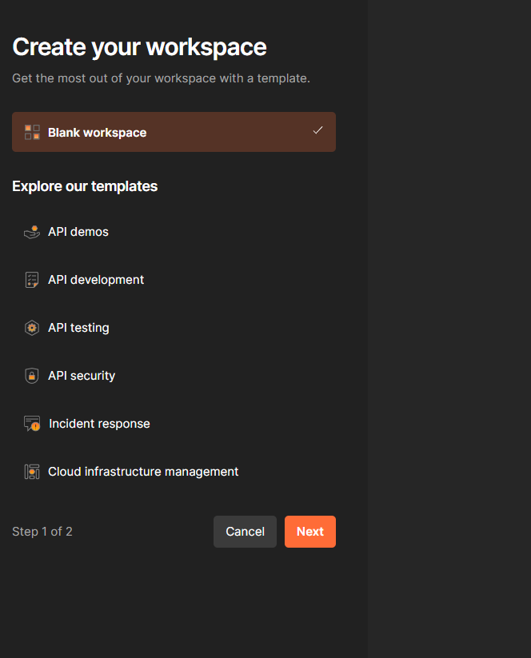

Give name for workspace creating. Choose type of workspace And then click on create workspace.

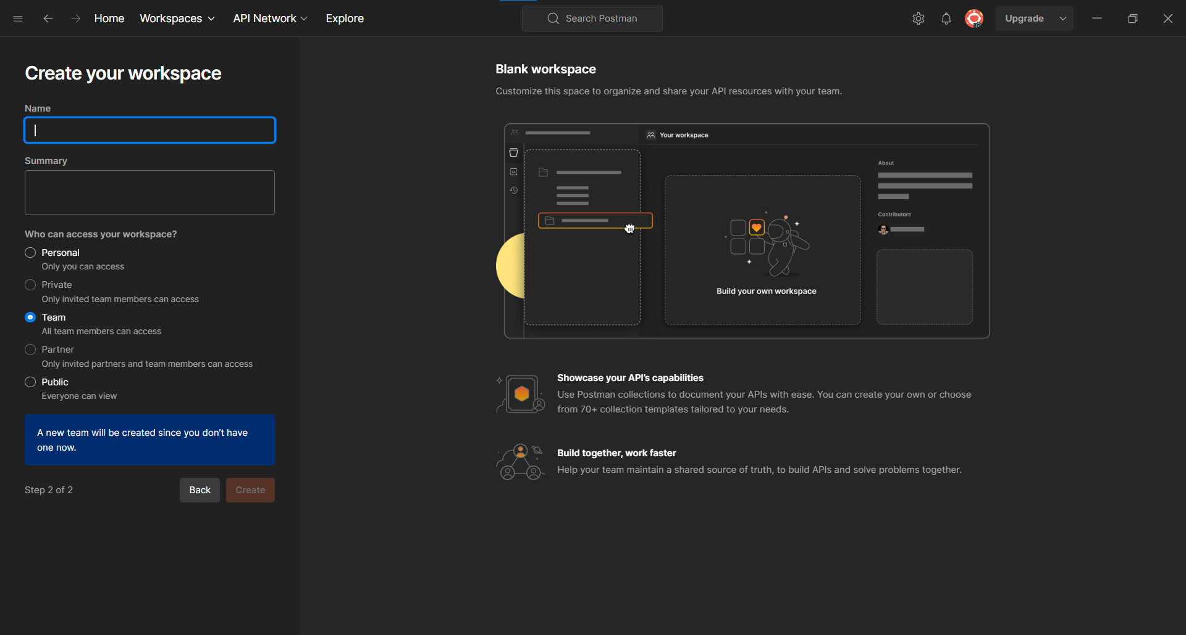

By click on create button and workspace will be created.

Create a collection first:

Click on ‘+’ button to add the collection and provide naming for that collection.

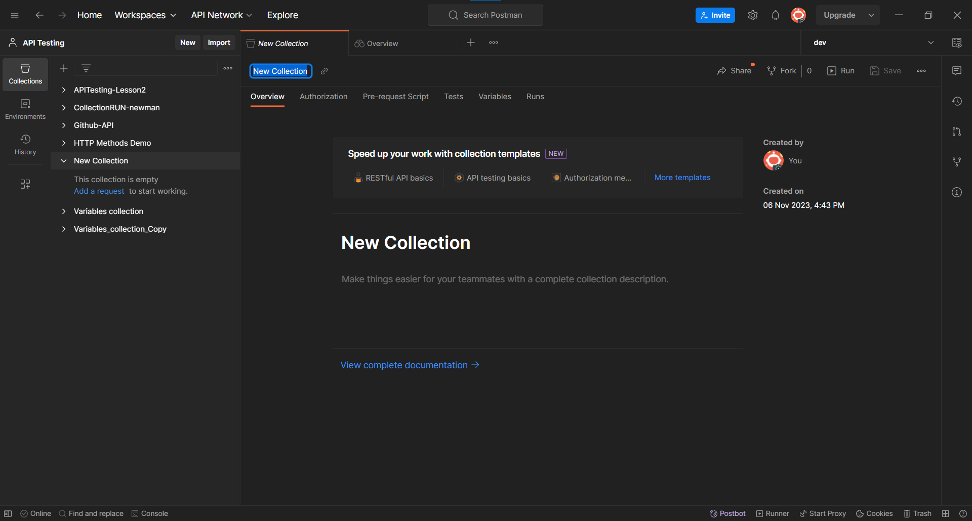

Give a name to the collection on right side:

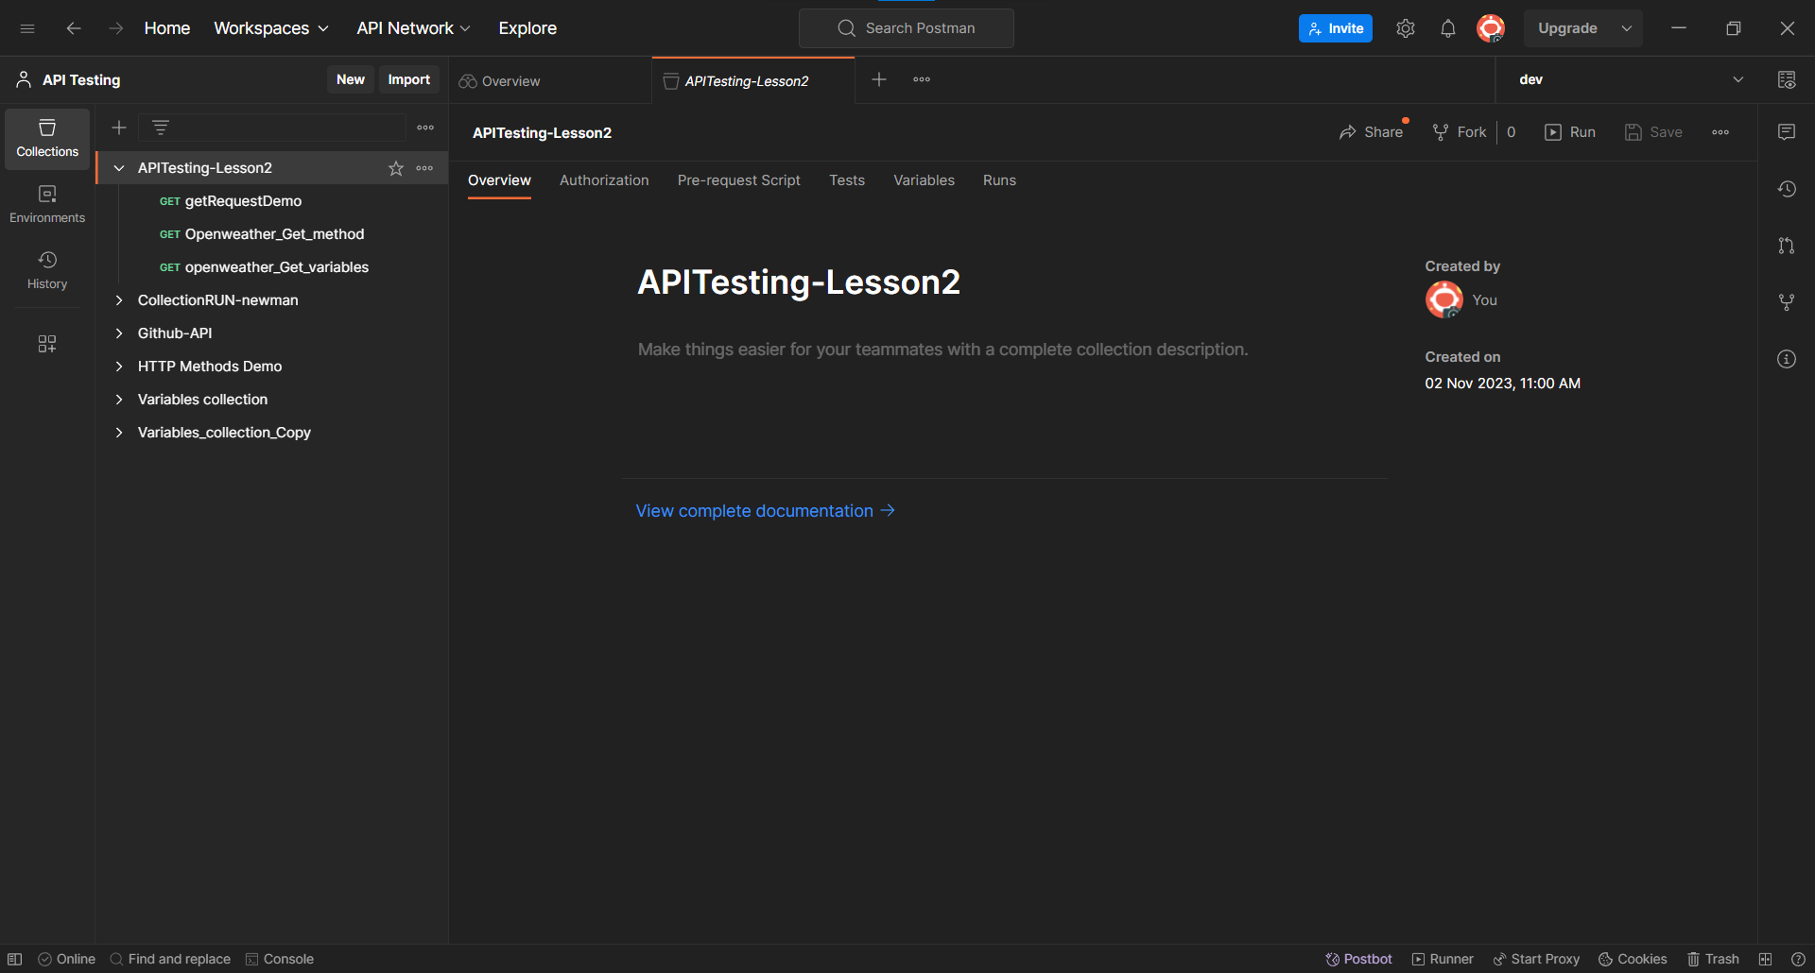

After created Collection. Create a request.

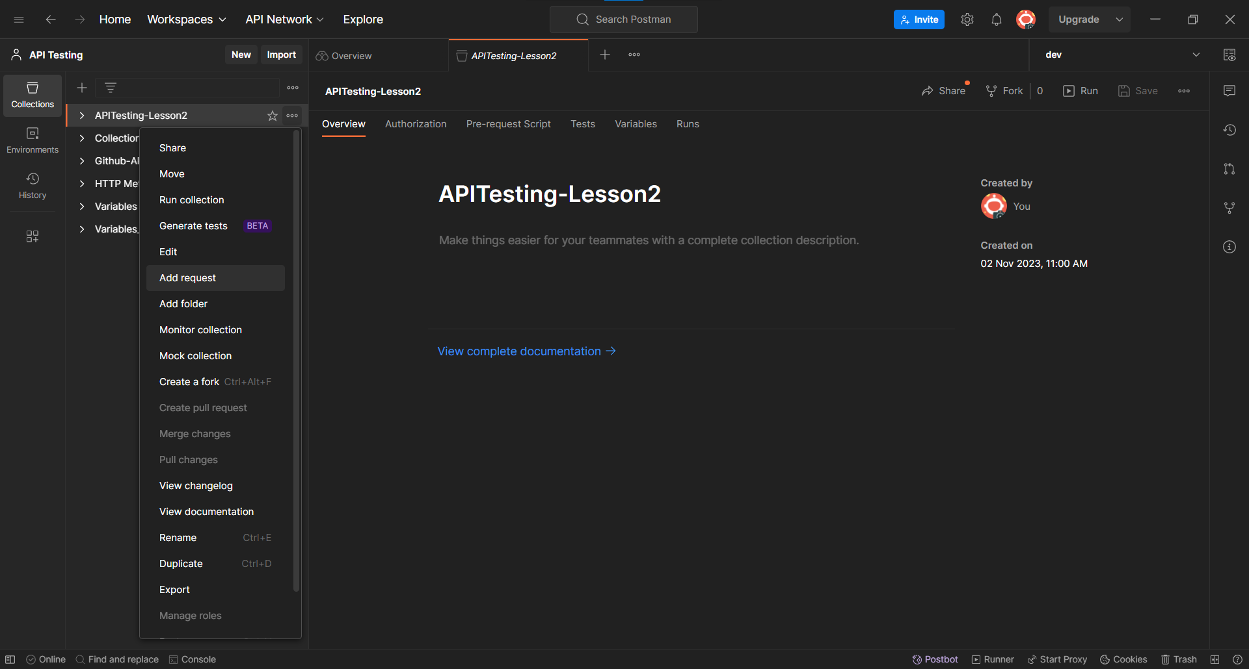

And then select the GET Method and give the https link.

After click on send button. If the request is success we can see the success message with status code as 200.

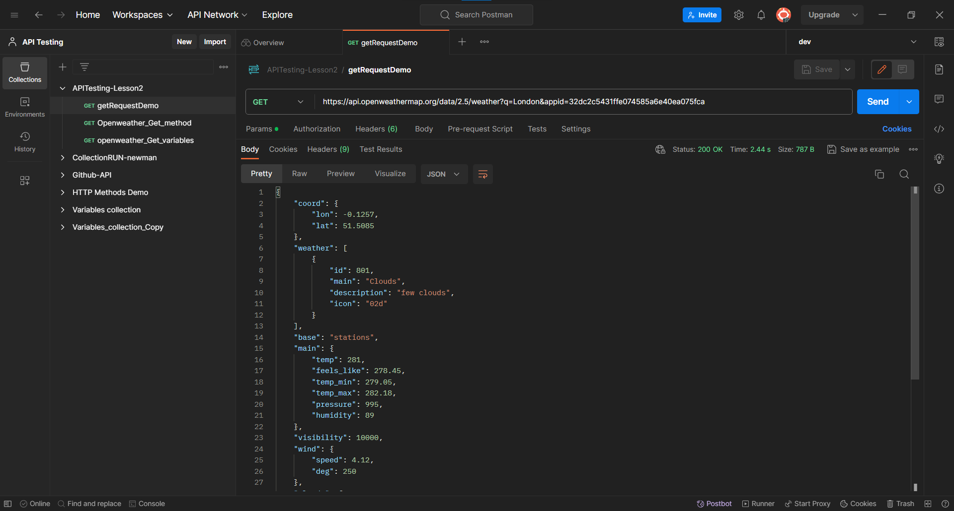

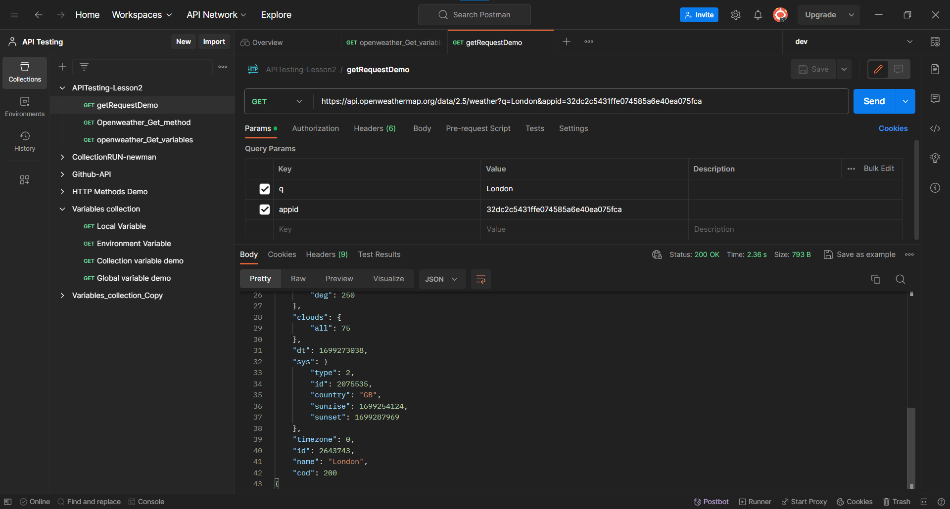

**Same Request By using different types of Variables:**

**Environment variable**

Created the new Environment with name of dev, by clicking on ‘+’ button.

And added the city variable with value as New York in environment as environment variable.

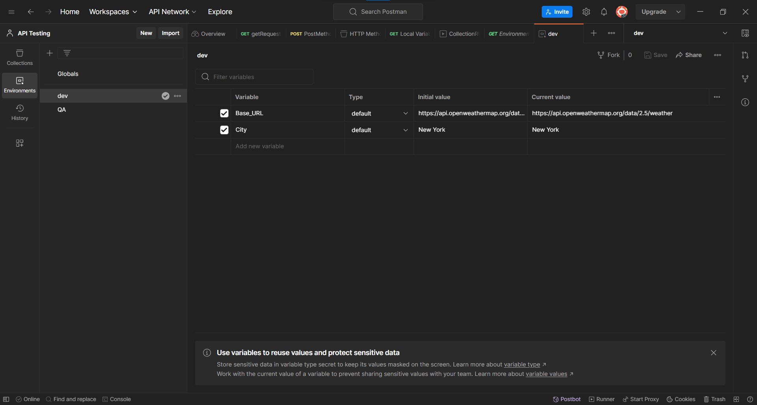

Here city variable takes the value from environment variable. As we set the environment to dev environment which contains city variable.

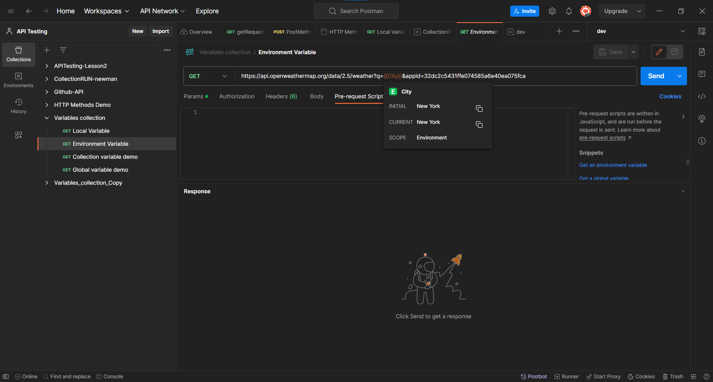

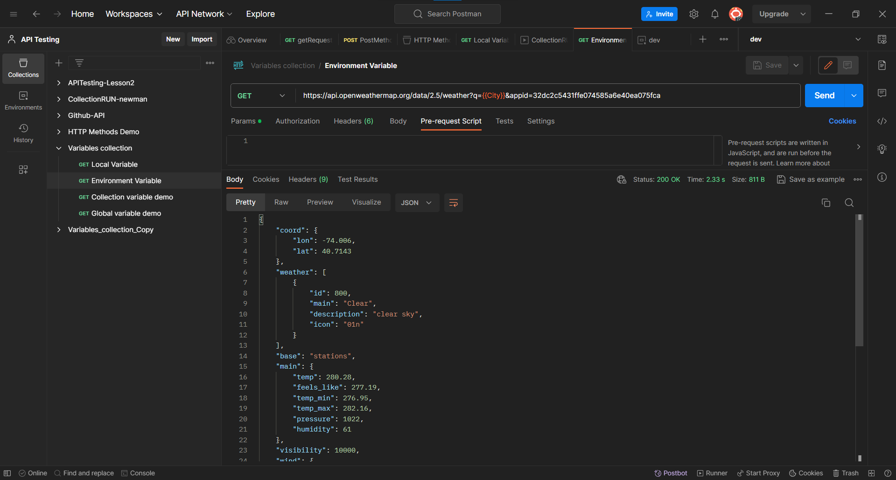

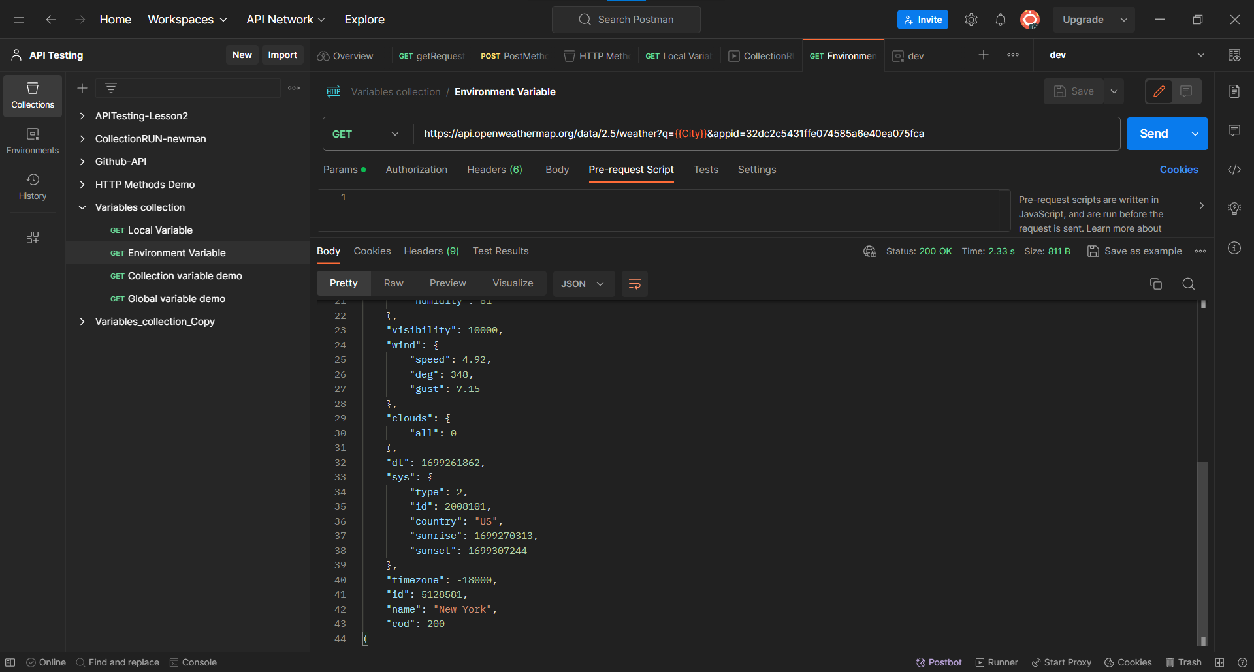

**Collection variables:** -> Collection level variable

A variable that will be available by default to every request in that collection only. This variable will be applicable even if you have not selected any environment.

Collection variable will always be created on collection dashboard

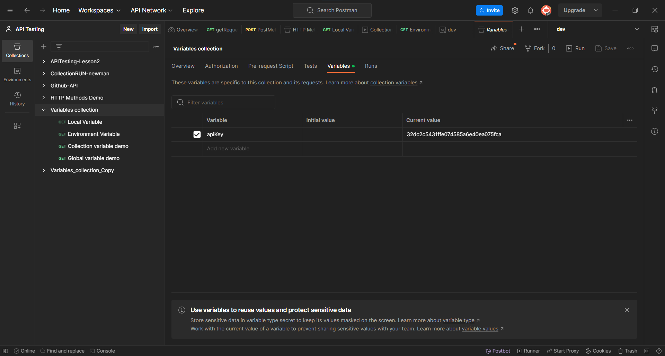

Added the request and selected the GET method.

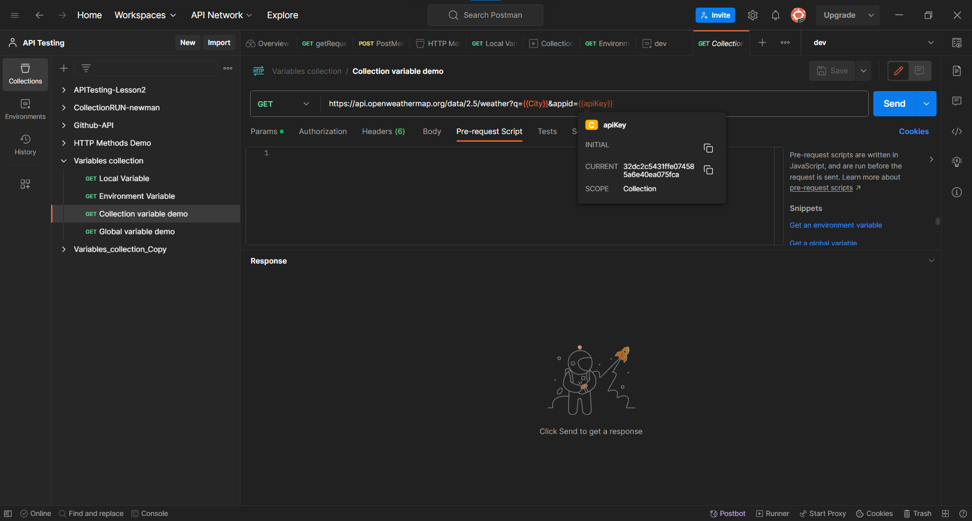

The apiKey variable sets from Collection variable. And city variable sets from the environmental variable.





**Global variables:**

The scope of global variables is along all environments , collections and requests.

Click on environment->global-> add the variable.

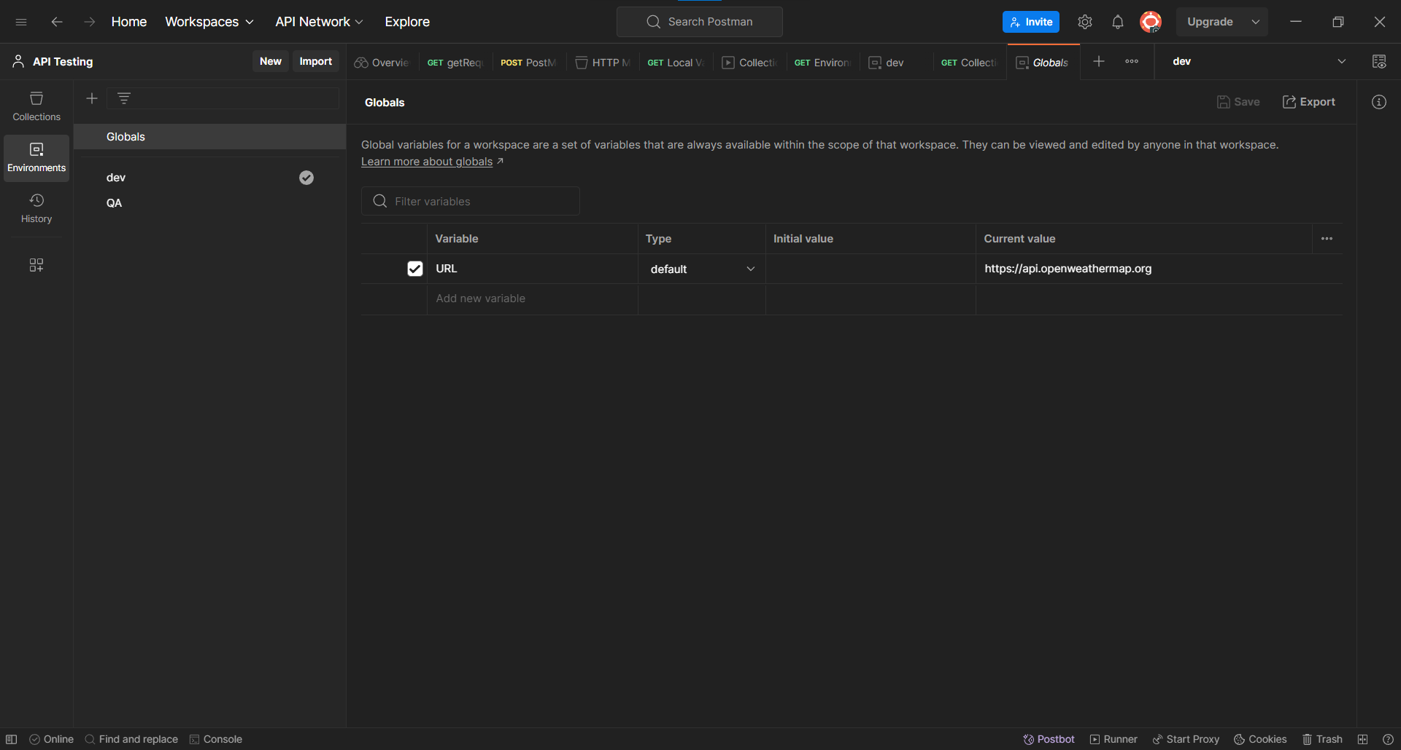

Created a request in the collection with name of global variable demo.

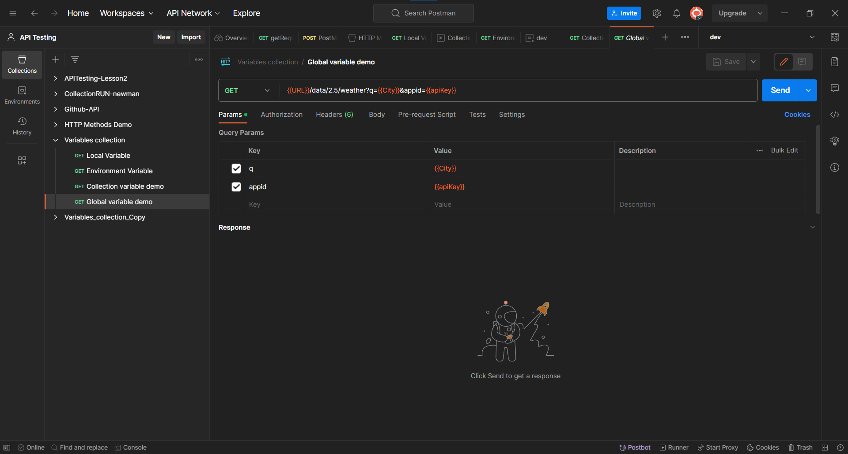

Here URL variable sets as the Global variable.

